# **Week12 Power Company Case**

## Problem

some people aren’t able to pay (not well meaning people not able to pay)

2 category of “could pay but dont“

1. They forgot (they want to keep power on)
2. They will never pay (so power company had to swtich off power)

## Challenge**:**

1. Manual shut off of power. Company workers have to drive around

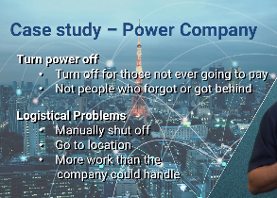

## Structure

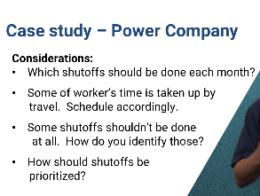

## Template

**“given”** what I know, “**use”** this model to “**obtain**” a result

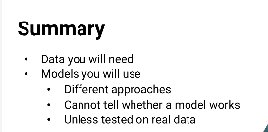

# Week 12 Power company Case study

# Ask:

Identify customers who can pay, but haven’t. Turn off power to the specific subset who are never going to pay.

# Challenge:

Logistical problem in manually sending employees to shutdown power across the city